BrightLearn — SQL Date Functions Exercise
Databricks SQL Submission — Query Results
Contains screenshots for Questions 1–20 plus the Bonus Challenge, in order.

Q1 — Day Name from Order Date
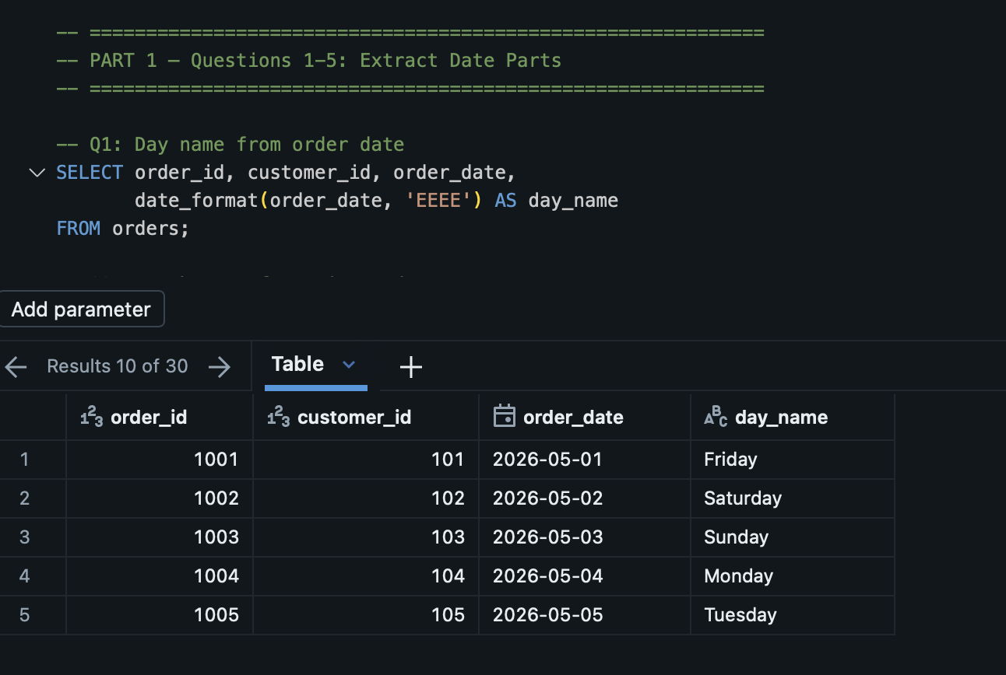

Q2 — Month Name from Signup Date
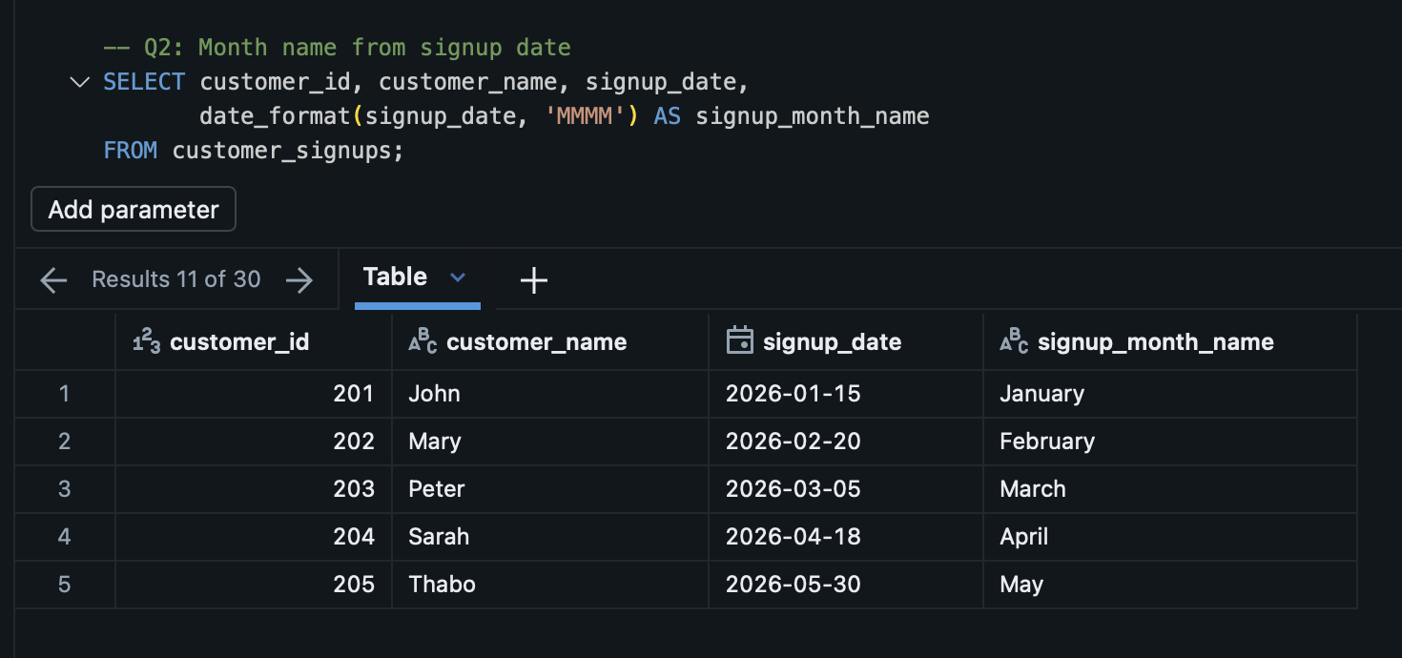

Q3 — Month Number from Sale Date
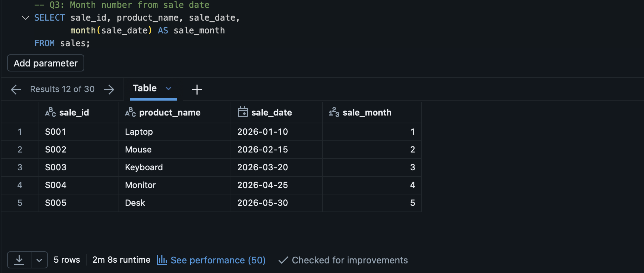

Q4 — Year from Transaction Date
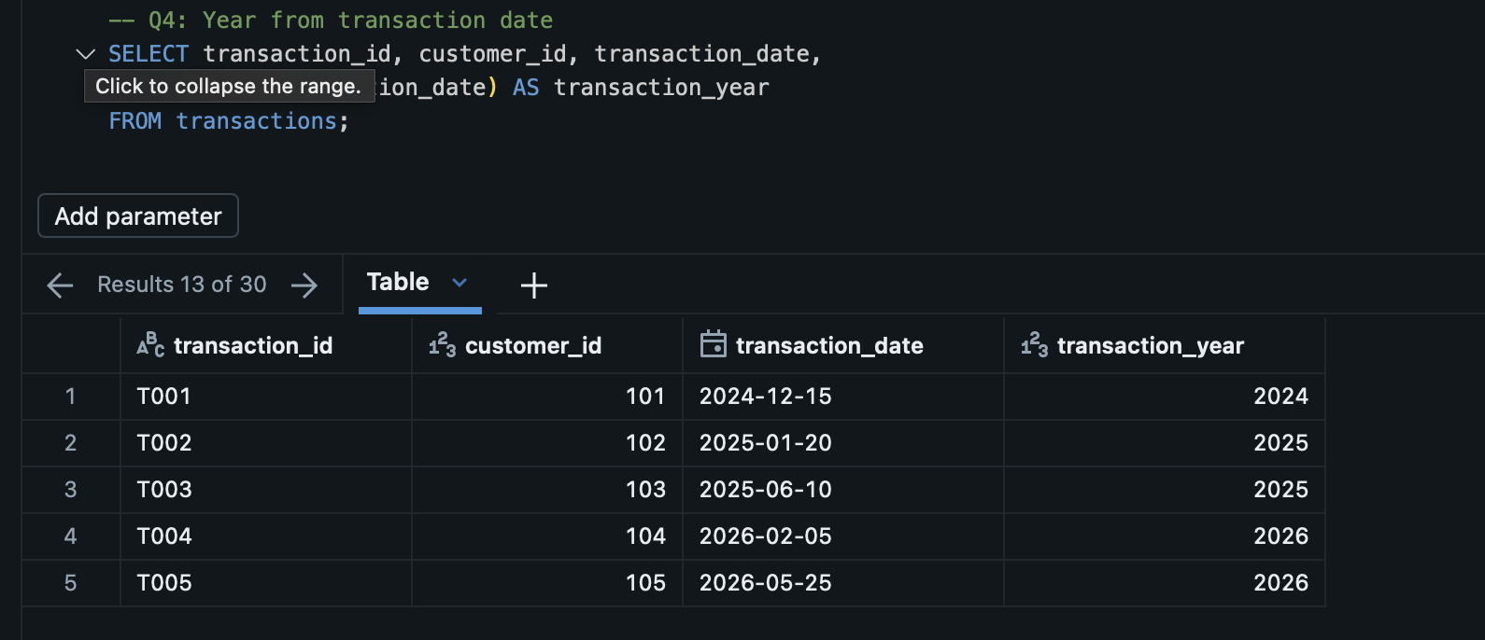

Q5 — Day of Month from Delivery Date
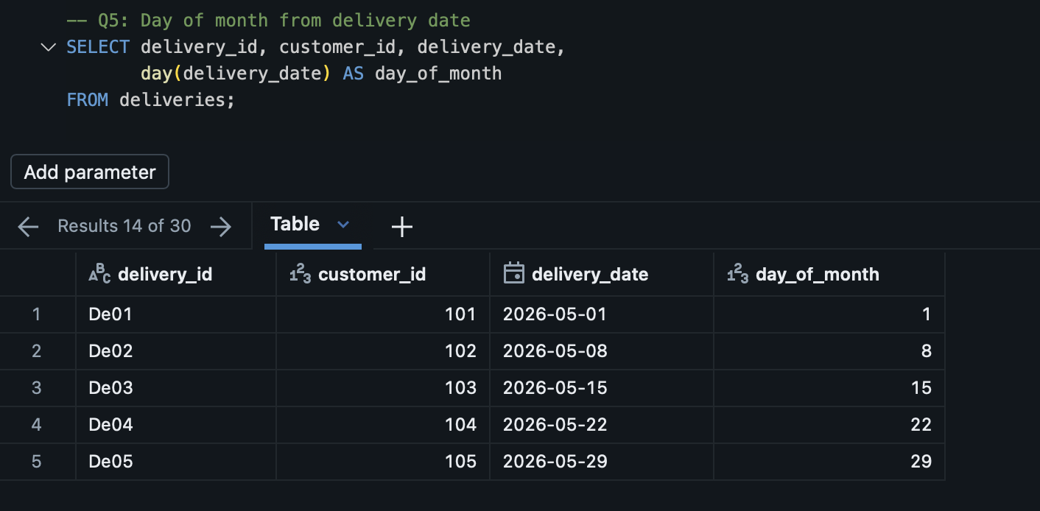

Q6 — Add Today's Date
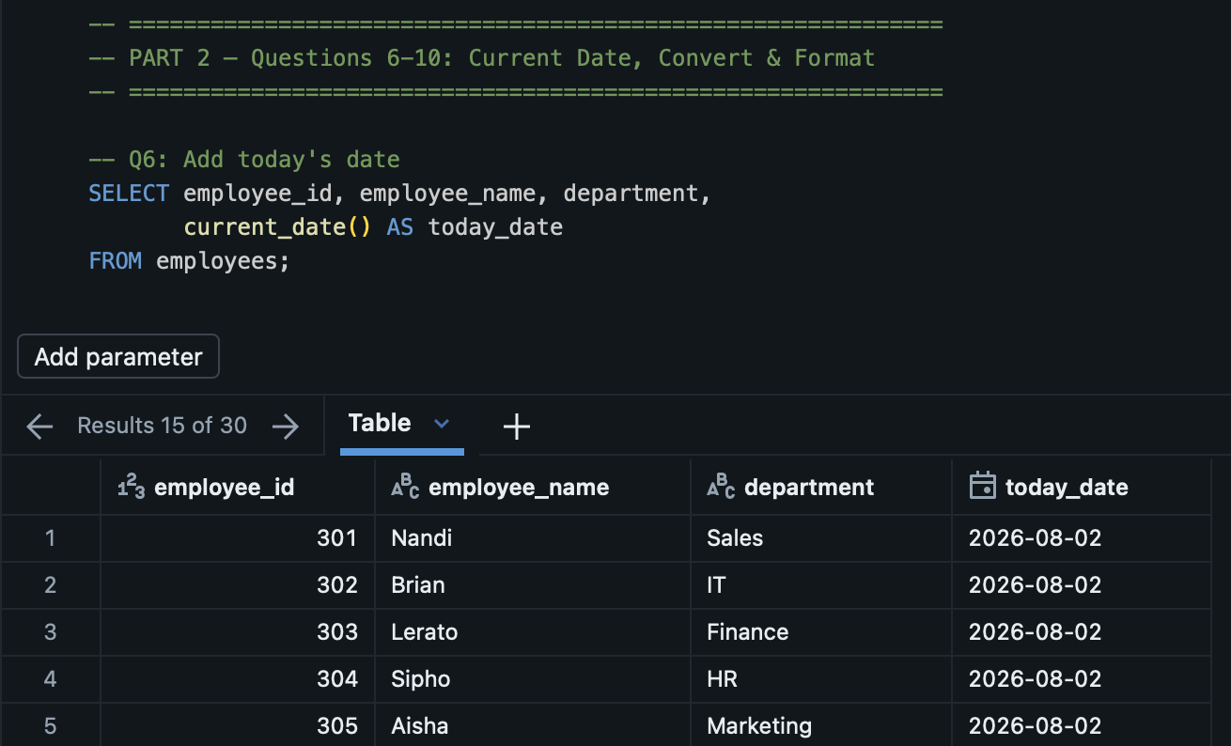

Q7 — Convert Text to Date
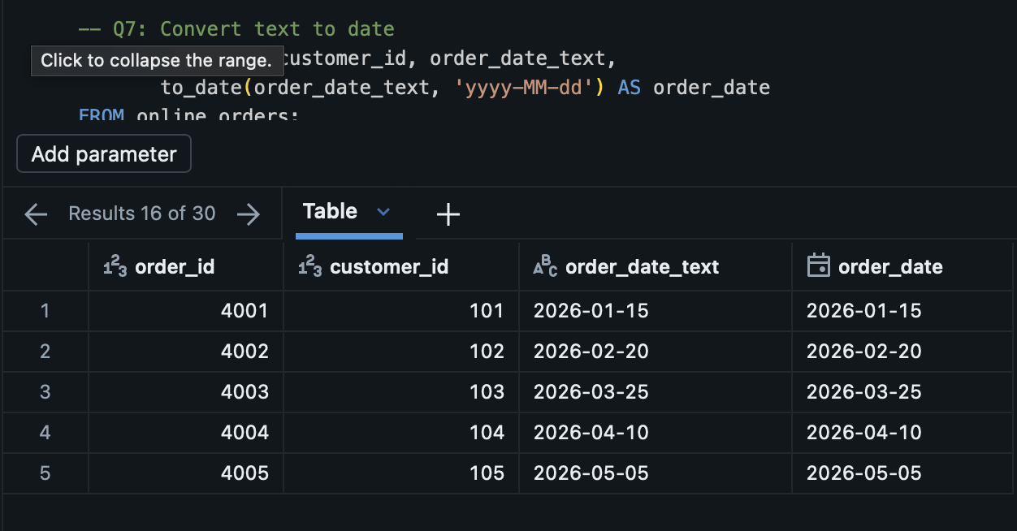

Q8 — Format Date as Text
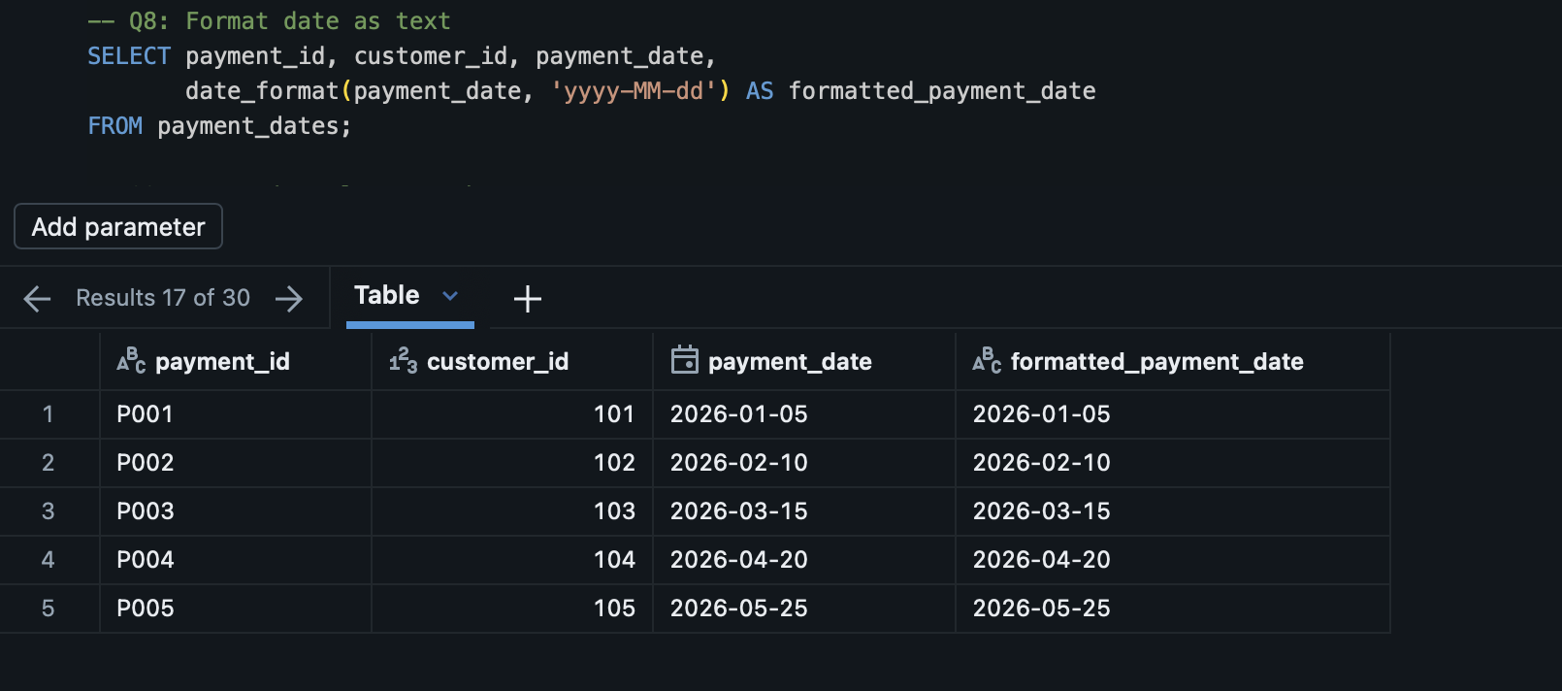

Q9 — Days Since Last Purchase
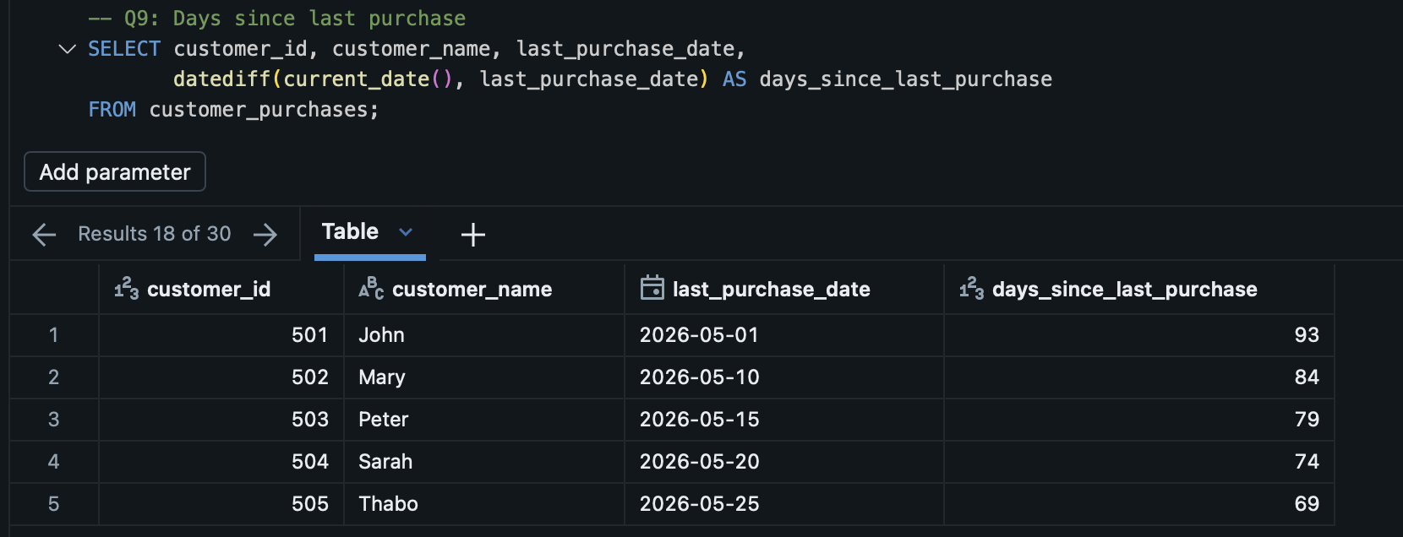

Q10 — Expected Delivery Date
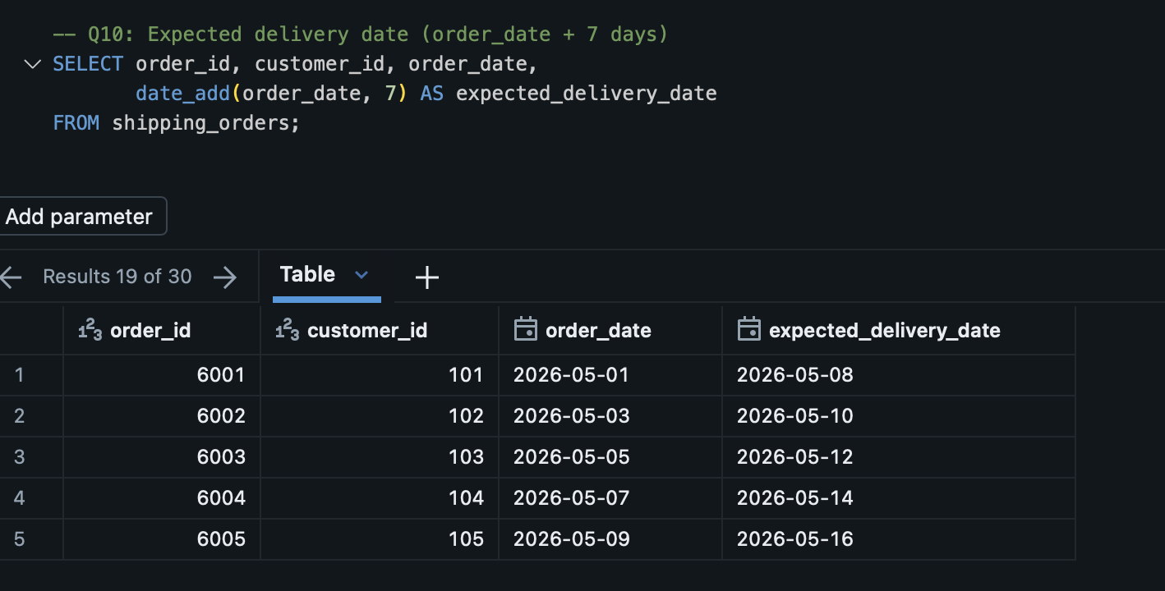

Q11 — Year, Month, Day Separately
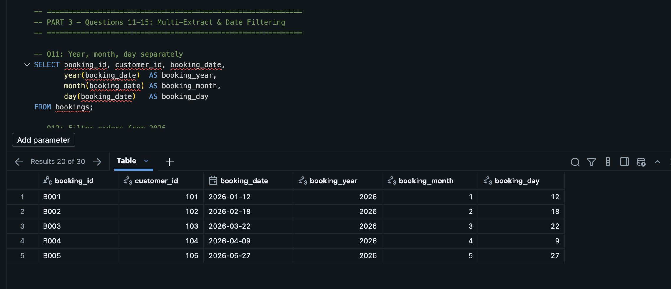

Q12 — Filter Orders from 2026
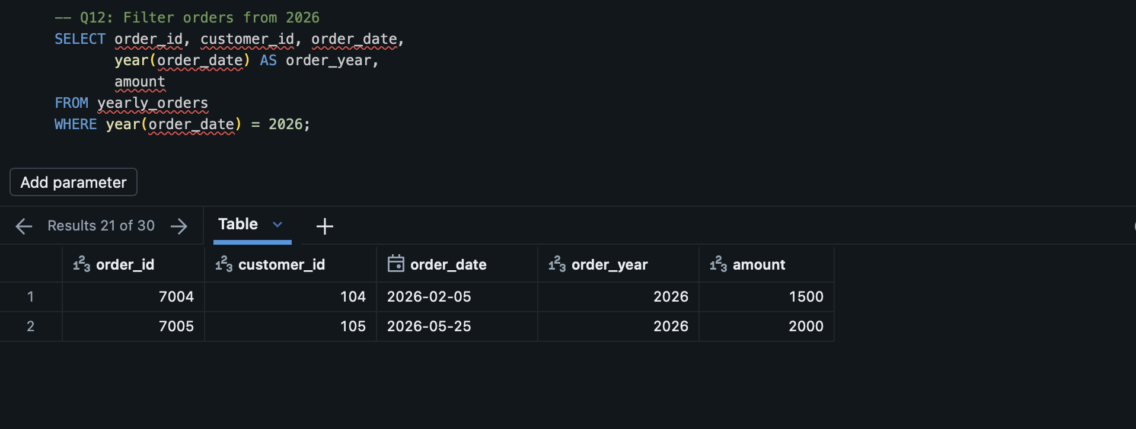

Q13 — Filter Orders from March
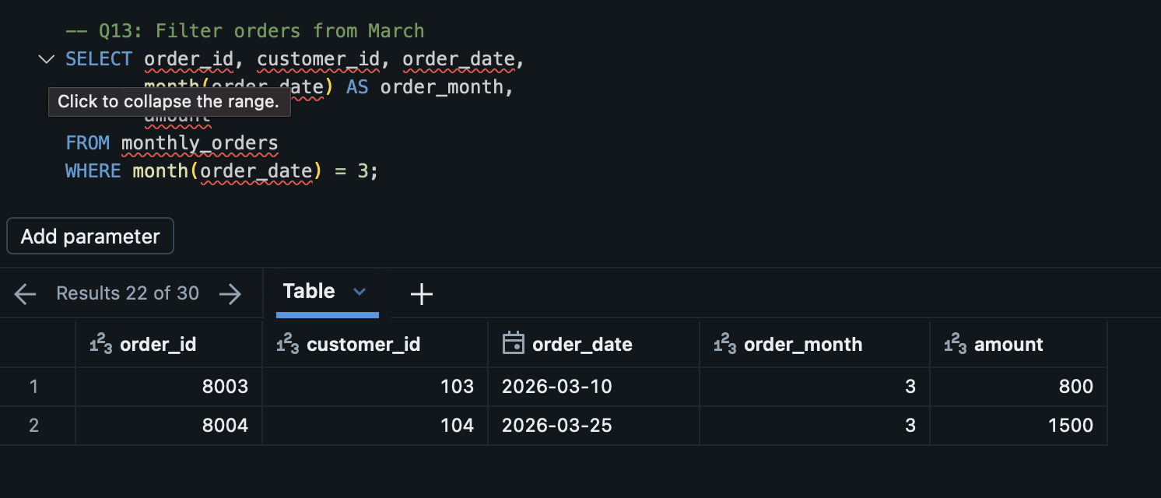

Q14 — Last Day of the Month
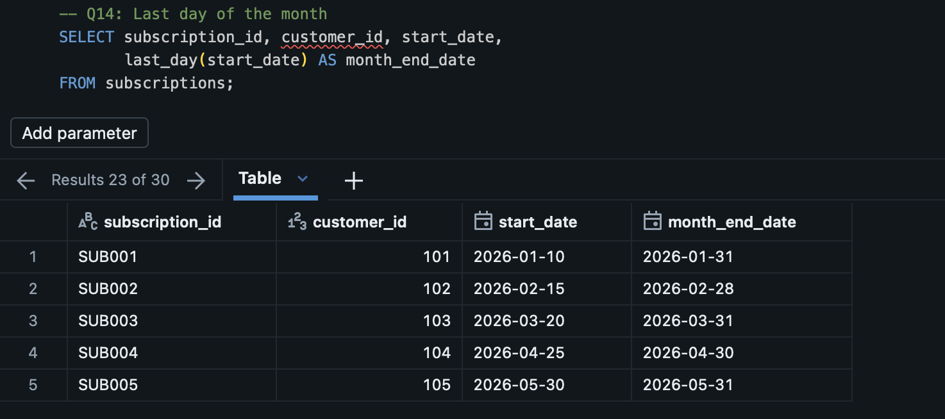

Q15 — First Day of the Month
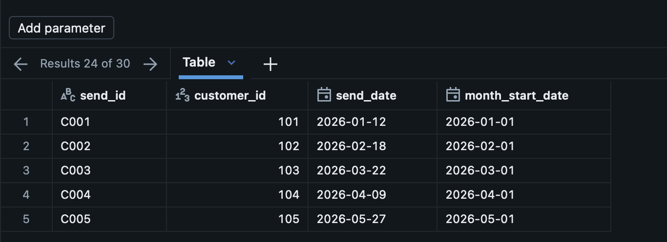

Q16 — Format as Month and Year
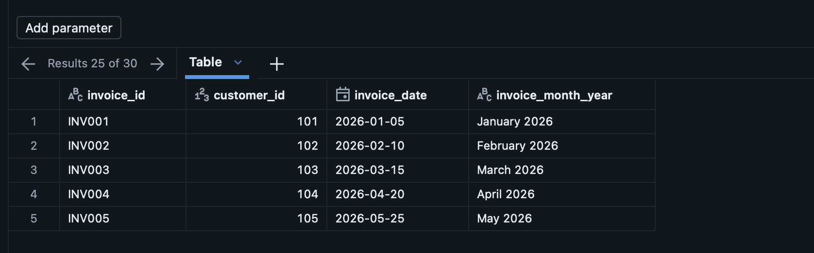

Q17 — Customer Age from Date of Birth
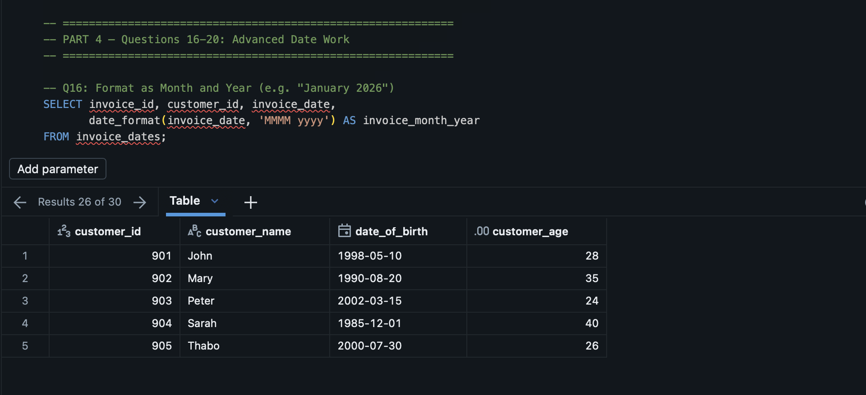

Q18 — Classify Weekend vs Weekday
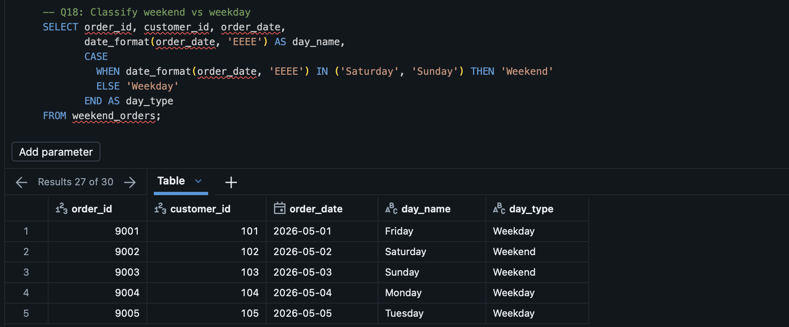

Q19 — Transactions by Quarter
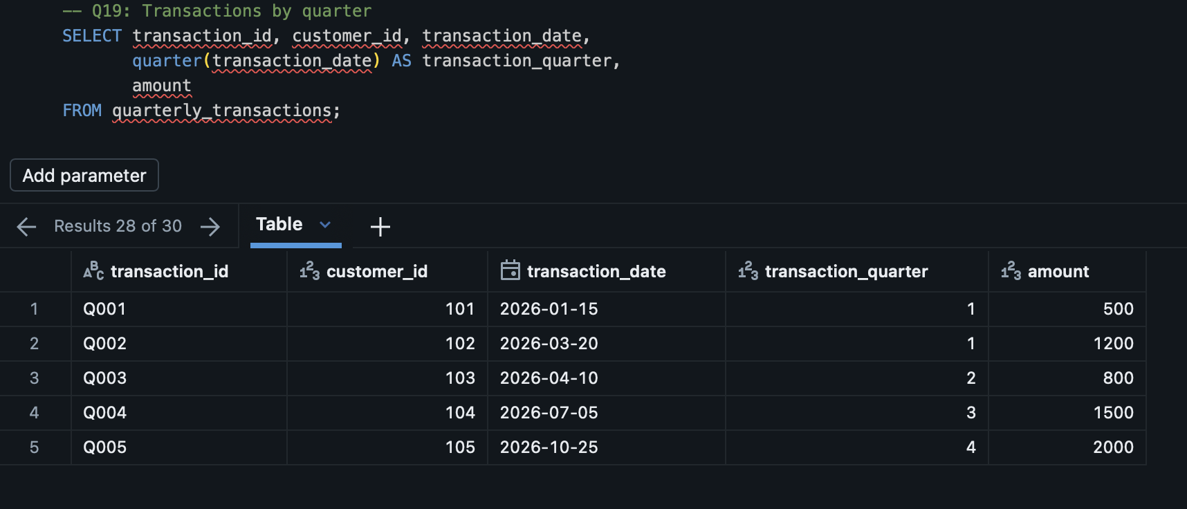

Q20 — Orders Older Than 30 Days
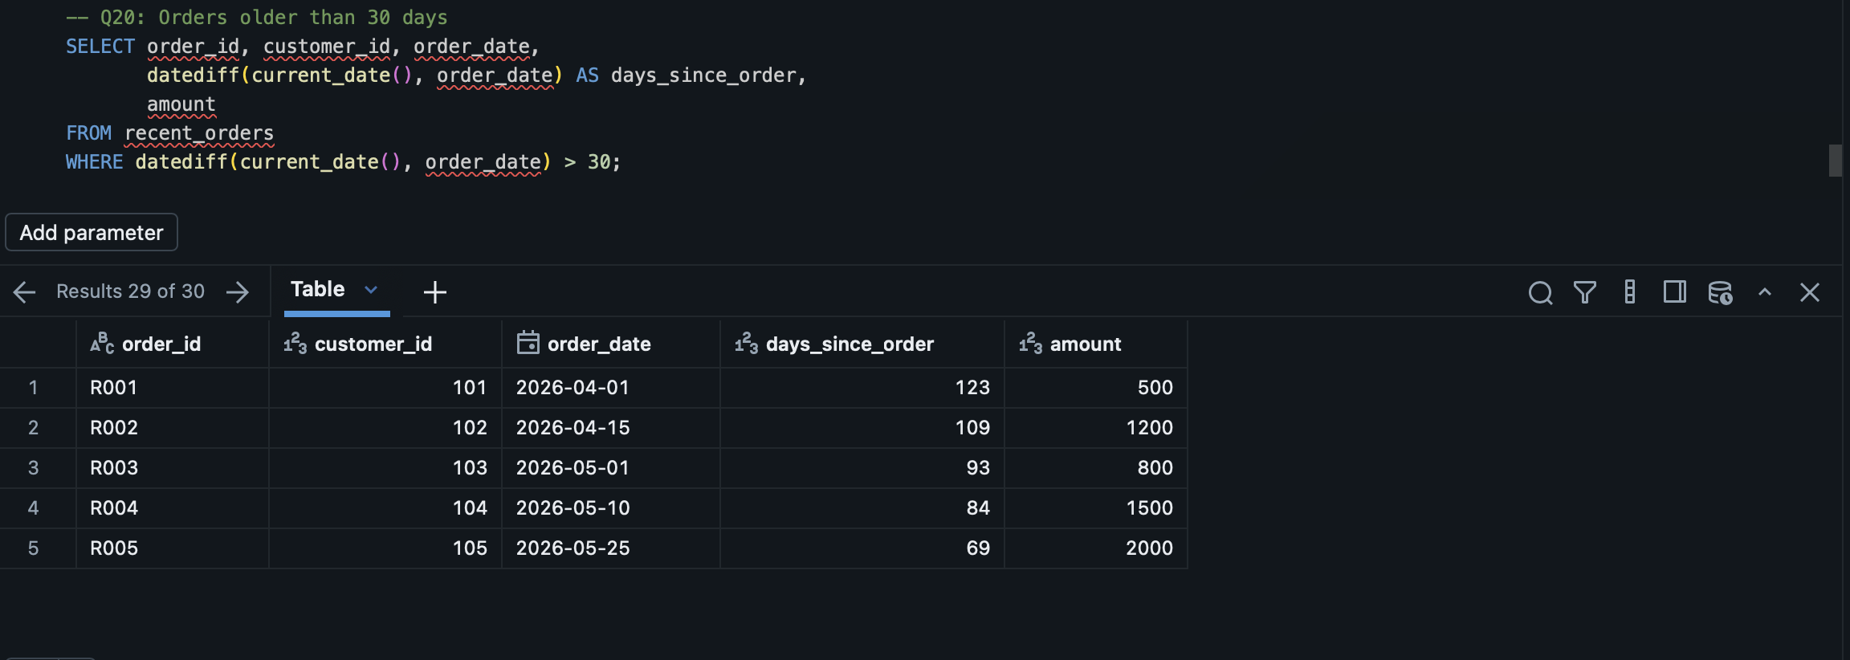

Bonus — Customer Recency Segment
